  - Nontraditional Learner Questionnaire

Directions: Read each question and enter a checkmark in the T/True or F/False column. Tally your responses at the bottom of the Questionnaire.
T F
1 | Did your child thrive in pre-school but then inexplicably begin to struggle in kindergarten?
2 | Has your child gone from being happy and carefree to anxious or frustrated?
3 | Has your child's teacher identified him or her as a struggling student or reader?
4 | Is your child beginning to dislike or complain about school?
5 | Do you feel your child is bright but the teacher or school isn't “getting” him?
6 | Is your child a natural born athlete, a high-energy child, or always on the go?
7 | Has your child shown relatively little interest or ability in learning to read compared to other siblings or children you know?
8 | Is your child highly inquisitive and always figuring things out?
9 | Has your child's teacher suggested he might have ADD or a learning disability of some kind?
10 | Has your child had private tutoring at home or help at school but shown little or no improvement?
11 | Are you feeling highly worried or overwhelmed with your child's school performance?
12 | Is your worry affecting your relationship with your child, your spouse or your family dynamic?
13 | Do you feel like your child is one of the only children struggling in the class?
14 | Are you feeling isolated from other parents at school and less willing to share what you and your child are going through?
Tally your responses and put totals to the right. Read page 2 for an interpretation.

Interpreting Questionnaire Results
If you responded T/True to 7 or more of the questions on the Questionnaire, it is likely that your child is a Nontraditional Learner. Your child is no less motivated or intelligent than other students. He or she is unintentionally being handicapped by classroom teaching methods that work best for traditional learners with Reading Dominant OptiKodes.

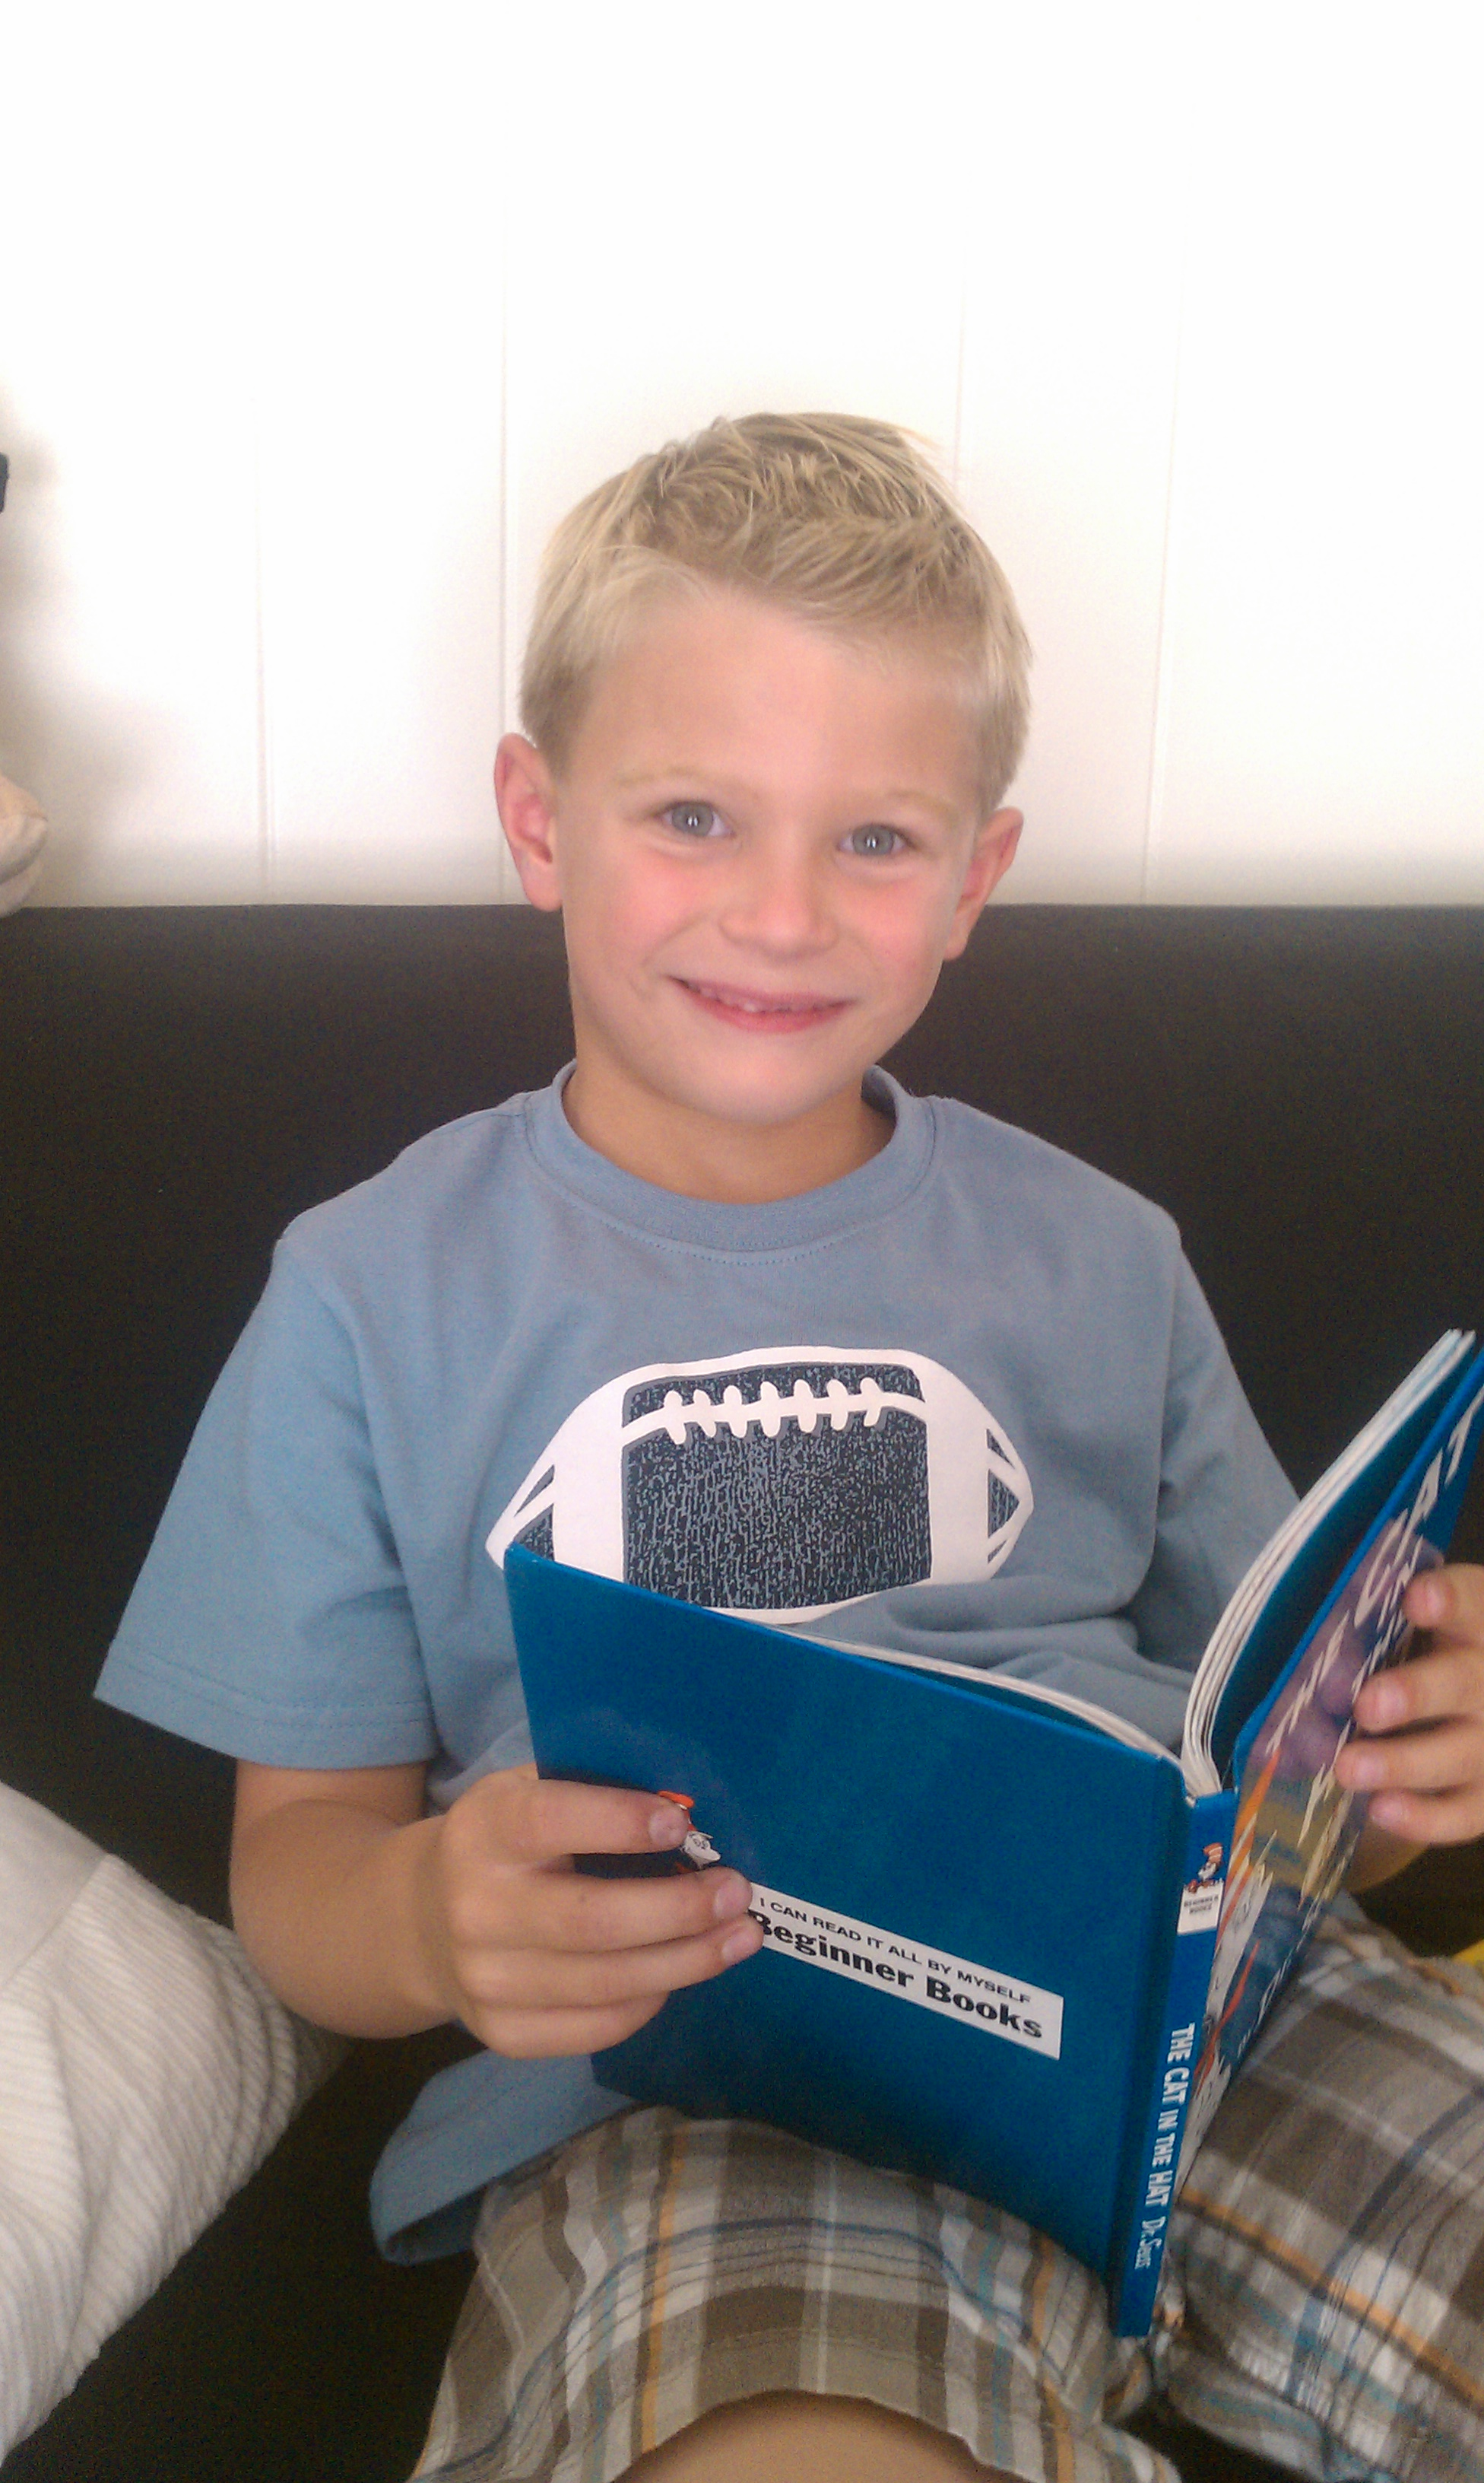
Characteristics of Nontraditional Learners:
- Often very inquisitive and math-minded
- Often very coordinated and good at sports
- Full of energy and very active
- Love to talk and verbalize
- Sometimes gifted at singing and musicianship
- Prefer to learn by doing or experiencing
- Like to dive right in on assignments and projects

Understanding and supporting your child:
Nontraditional learners don’t thrive with a large emphasis on book learning which is the traditional approach used in classrooms. Learners like your child do well when learning involves the other 4 OptiKode Learning Modalities: Seeing, Thinking, Hearing and Moving depending on how they are ranked in his or her OptiKode.

What can I do to bring out the natural born learner in my child?
- Visit OptiKodes.com and discover your child’s OptiKode Learning Style. You will learn in less than 10 minutes whether your child is a nontraditional learner and whether they are at risk for struggling in reading, math or both subjects.

- Schedule a 75-minute Family OptiKodes Evaluation and learn about all the OptiKodes in your family. You will learn how to work more effectively as a family and how to bring out the best in everyone.

- Schedule a Discover Your Child’s OptiKode evaluation with Kimberley Blackburn, M.A. These 75-minute sessions can be done in person or over Skype and are guaranteed to reboot how your understand your child and how you help them reach their full potential.

